UNIVERSITY INSTITUTE OF COMPUTING

**PROJECT REPORT**

**ON**

**Advertisement Poster**

Program name: BCA

Subject Name/Code: Desktop Publishing

Lab(23CAP-204)

**Submitted by: Submitted to:**

**Name:** Utsav Raj **Name: Mr.** Jitendra Kr.

**UID:** 23BCA10816 **Designation:** Assistant

**Section:** BCA – 3 “B” professor

**Git hub: https://github.com/Utsavrajlohani/ad-banner.git**

**ABSTRACT**

**Introduction of Adobe Photoshop:**

Adobe Photoshop is a critical tool for designers, web developers, graphic artists, photographers, and creative professionals. It is widely used for image editing, retouching, creating image compositions, website mock ups, and adding affects.

* **Uses**: Photoshop is used for a variety of tasks, including:
  + Retouching images
  + Correcting lighting
  + Adjusting photo composition
  + Creating image compositions
  + Adding effects
  + Creating website mock ups
  + Creating website layouts

**. Required Tool Used in:**

* Rectangle Tool
* Text Tool
* Move Tool
* Triangle Tool
* Background Tool
* Pen Tool

1. **Aim/Overview of the practical:**

To design a promotional advertisement poster for a company using desktop publishing tools, showcasing both the company’s mission and product portfolio. The focus is on formatting and layout design principles for effective marketing communication.

1. **Task to be done:**

Create a brochure layout featuring a company profile. Include details such as "About Us", "Aim", contact information, and a display of product offerings. Use appropriate formatting, typography, and image integration.

1. **Algorithm/ Flowchart:**

Step 1: Gather company information (About Us, Aim, contact details, products).

Step 2: Choose layout structure (decide on sections: headers, text blocks, and images).

Step 3: Input text for "About Us", "Aim", and other relevant information.

Step 4: Insert product images and company logos.

Step 5: Apply formatting (bold text for section headers, image placement, colour scheme).

Step 6: Review for consistency in formatting and alignment.

1. **Dataset:**

**About Us:**

Coca-Cola India is a leading beverage company offering a wide range of drinks including Coca-Cola, Thums Up, Sprite, Mazza, and Minute Maid. The company focuses on sustainability, water conservation, recycling, and community initiatives.

**Aim:**

Coca-Cola India aims to refresh the nation with a diverse beverage portfolio while promoting sustainable growth, environmental stewardship, and community development, having a positive impact on both people and the planet.

**Products:**

Coca-Cola, Thums Up, Sprite, Mazza, Minute Maid.

**Contact Information:**

**Address:**

Level 18, One Horizon Centre, Golf Course Road, Horizon Colony, Sector 43, Gurugram, Haryana 122002

**Consumer Support:** 1-800-438-2653

**Media:** 1-888-348-2404

1. **Code for experiment/practical:**

N/A (This is a design-oriented task, created in adobe photoshop)

1. **Result/Output/Writing Summary:**

The final output is a professional Coca-Cola ad-poster featuring detailed information about the company’s sustainability efforts, product offerings, and contact details. The layout is clean and visually engaging, with emphasis on product images and a clear company mission statement.

**Learning outcomes (What I have learnt About):**

1. How to design an effective marketing poster using desktop publishing software.

2. Understanding the importance of layout, typography, and image placement in design.

3. How to format text to make important sections stand out (bold, italics, etc.).

4. Integrating logos and product images into a visually appealing layout.

5. The role of corporate sustainability messaging in promotional materials.

**Input:**

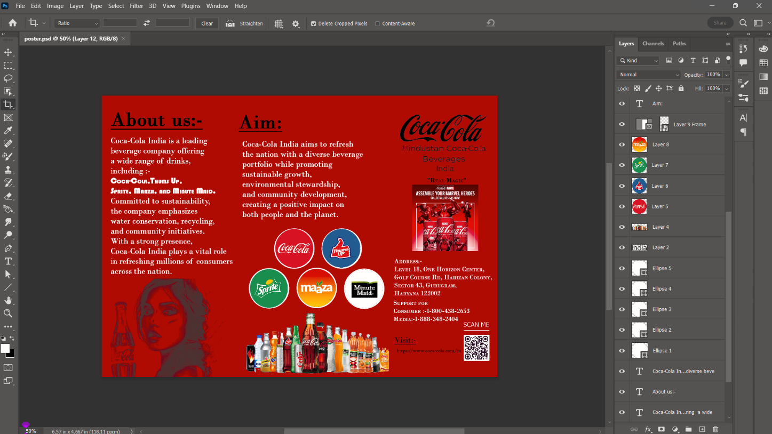

**Output:**

